# CS 255 System Design Document Template

This template lays out all the different sections that you need to complete for Project Two. Each section has guidance to prompt your thinking. You will need to continually reference the interview transcript as you work to make sure that you are addressing your client’s needs. There is no required length for the final document. Instead the goal is to complete each section based on what your client’s needs are. Remove this note when you are finished, and replace all bracketed text with the relevant information.

## UML Diagrams

## UML Use Case Diagram

### UML Activity Diagrams

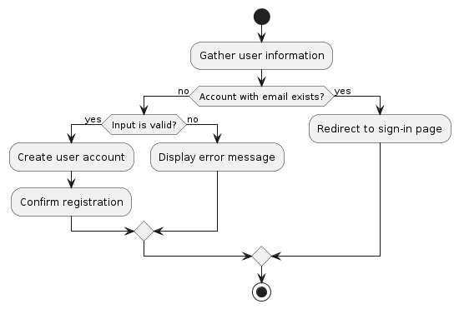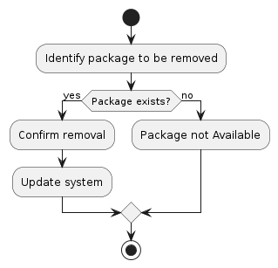

### UML Sequence Diagram

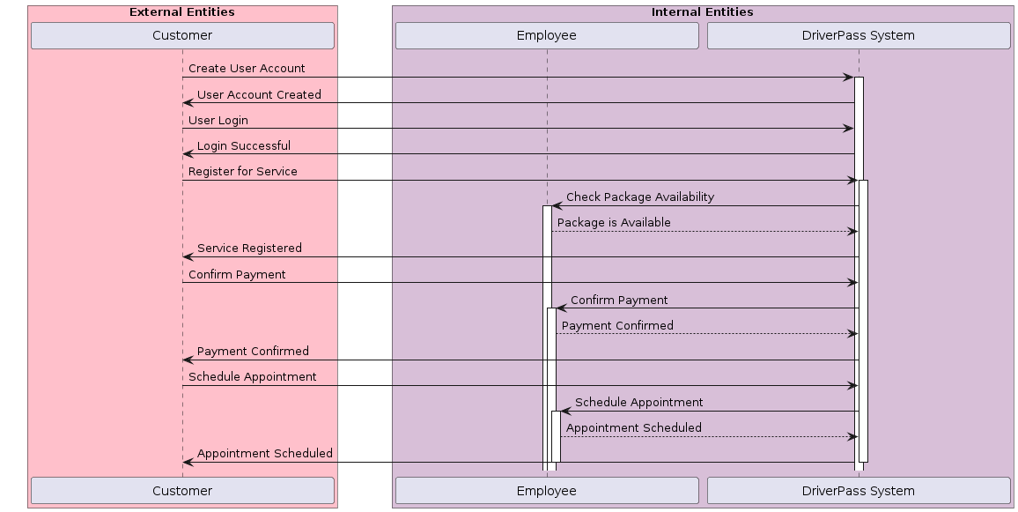

### UML Class Diagram

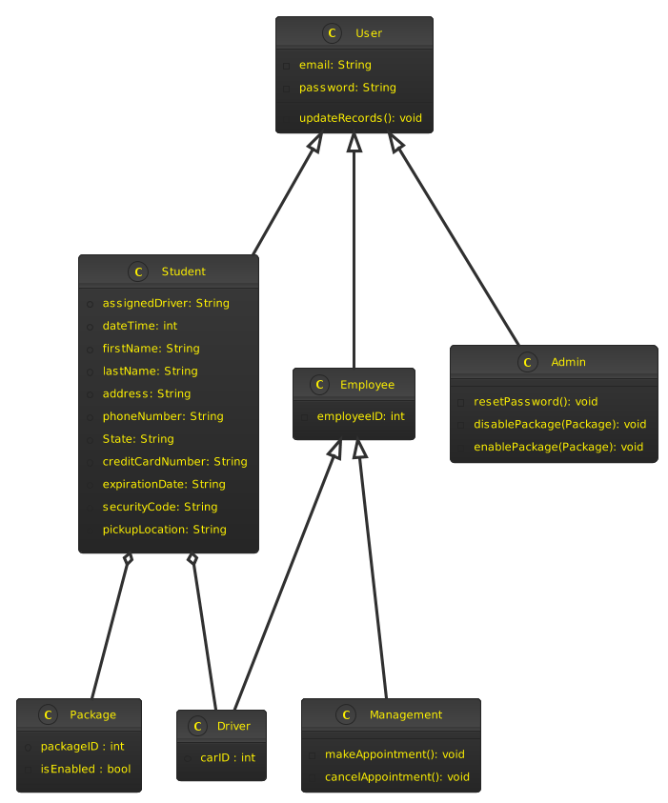

## Technical Requirements

The system requires servers, including a database server, and networking equipment to host the application and store user data securely. Software needs include an operating system, web server, database management system (DBMS), application framework, and programming languages for application development. Tools such as integrated development environments (IDEs) and project management tools facilitate development and collaboration. Cloud infrastructure like AWS or Azure provides scalability and flexibility, with high availability ensured through redundancy and failover mechanisms. These technical requirements lay the groundwork for developing and deploying the system effectively. Security measures, while crucial, are not included for simplicity reasons.